Add 1 to a number represented by LL
Problem Statement: Given the head of a singly linked list representing a positive integer number. Each node of the linked list represents a digit of the number, with the 1st node containing the leftmost digit of the number and so on. The task is to add one to the value represented by the linked list and return the head of a linked list containing the final value.
The number will contain no leading zeroes except when the value represented is zero itself.

Algorithm
Since the least significant digit is at the end of the list, we can’t process it directly using a single traversal. Therefore, to perform addition from the end, we need to reverse the list.
- Reverse the list and start from the head and add 1. Carry it forward as needed.
- If a carry remains after the last node, add a new node with value 1.
- Reverse the list again to restore the original order and return the head of the modified list.
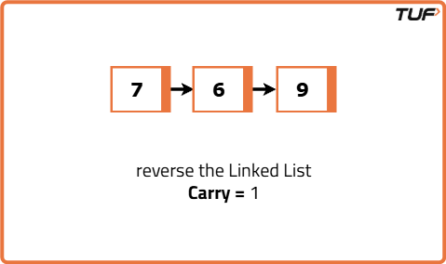

// Node class representing a single digit in the linked list
class Node {
int data;
Node next;

Node(int value) {
data = value;
next = null;
}
}

// LinkedList class to manage node-level operations
class LinkedList {
// function to insert digit at the end
Node append(Node head, int value) {
Node newNode = new Node(value);
if (head == null) {
return newNode;
}
Node current = head;
while (current.next != null)
current = current.next;
current.next = newNode;
return head;
}

// Function to print the list
void printList(Node head) {
Node current = head;
while (current != null) {
System.out.print(current.data);
current = current.next;
}
System.out.println();
}
}

// Solution class having the addOne logic
class Solution {
// function to reverse the linked list
Node reverseList(Node node) {
Node prev = null;
Node current = node;

while (current != null) {
Node nextNode = current.next;
current.next = prev;
prev = current;
current = nextNode;
}
return prev;
}

// Function to add one to the number represented by the linked list
Node addOne(Node head) {
// Reverse the list to make least significant digit accessible
head = reverseList(head);

Node current = head;
int carry = 1;

// Traverse the list and add carry
while (current != null && carry > 0) {
int sum = current.data + carry;
current.data = sum % 10;
carry = sum / 10;

// If there's no next node and we still have a carry, append a new node
if (current.next == null && carry > 0) {
current.next = new Node(carry);
carry = 0;
}

current = current.next;
}

// Reverse the list back to restore original order
head = reverseList(head);
return head;
}
}

